jSECTION 8.6

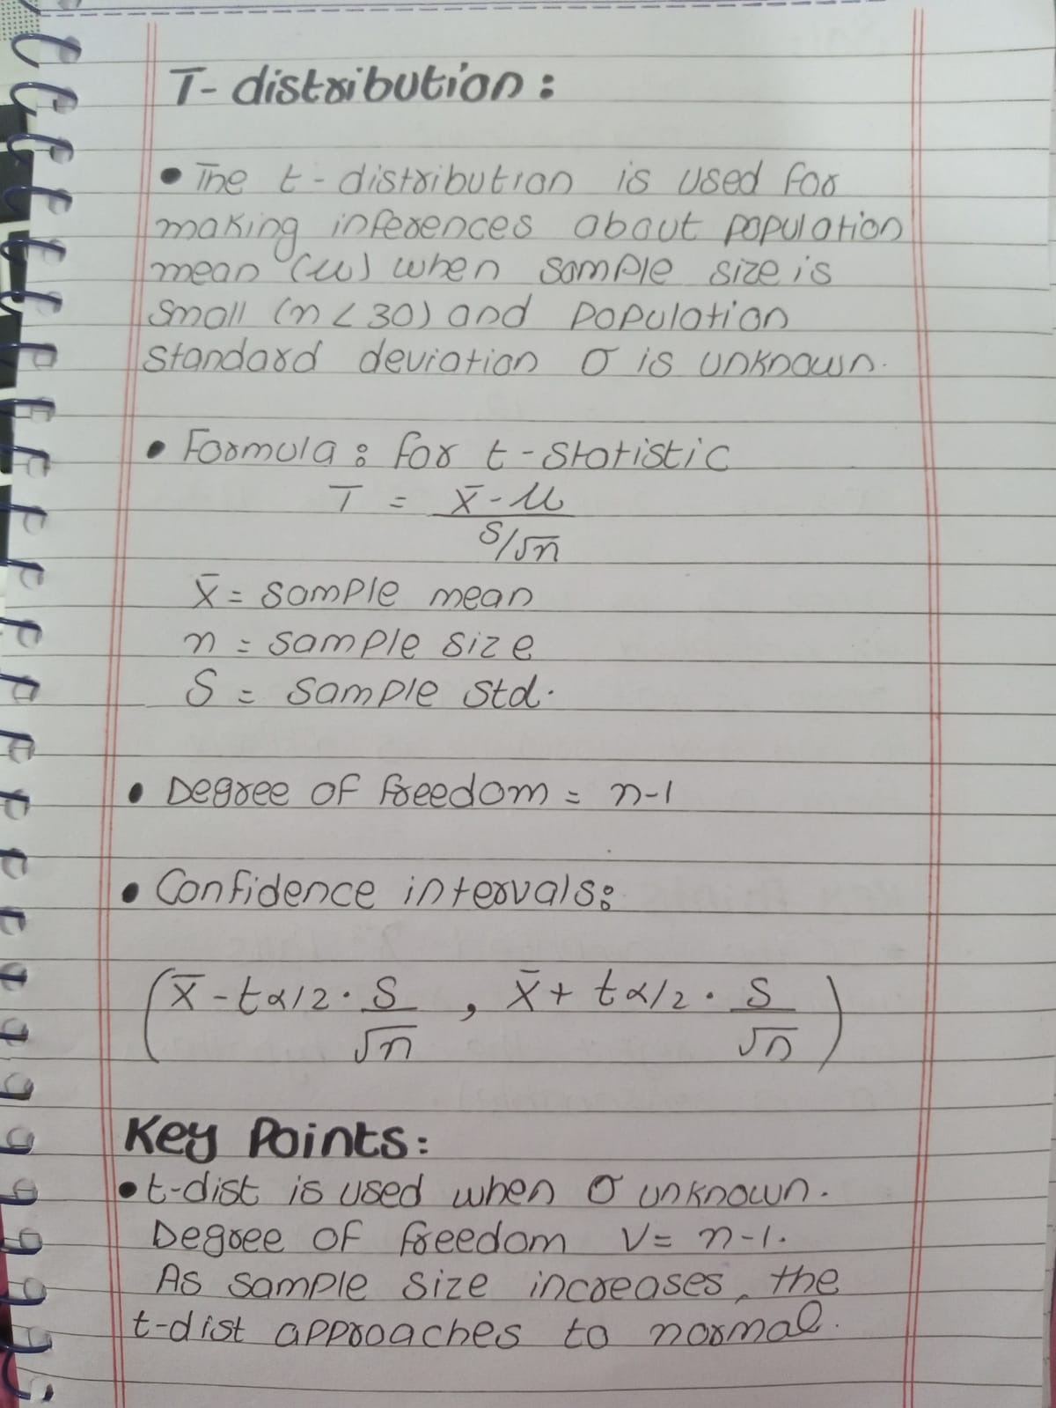

Example 8.11: Hypothesis Testing with t-Distribution
Question:
- A chemical engineer claims that the population mean yield of a batch process is 500 grams per milliliter of raw material. To check this claim, the engineer samples 25 batches each month. If the computed t-value falls between −t0.05 ​ and t0.05 the engineer will be satisfied with this claim. What conclusion should the engineer draw from a sample with a mean X̄ = 518 grams per milliliter and a sample standard deviation S=40 grams?
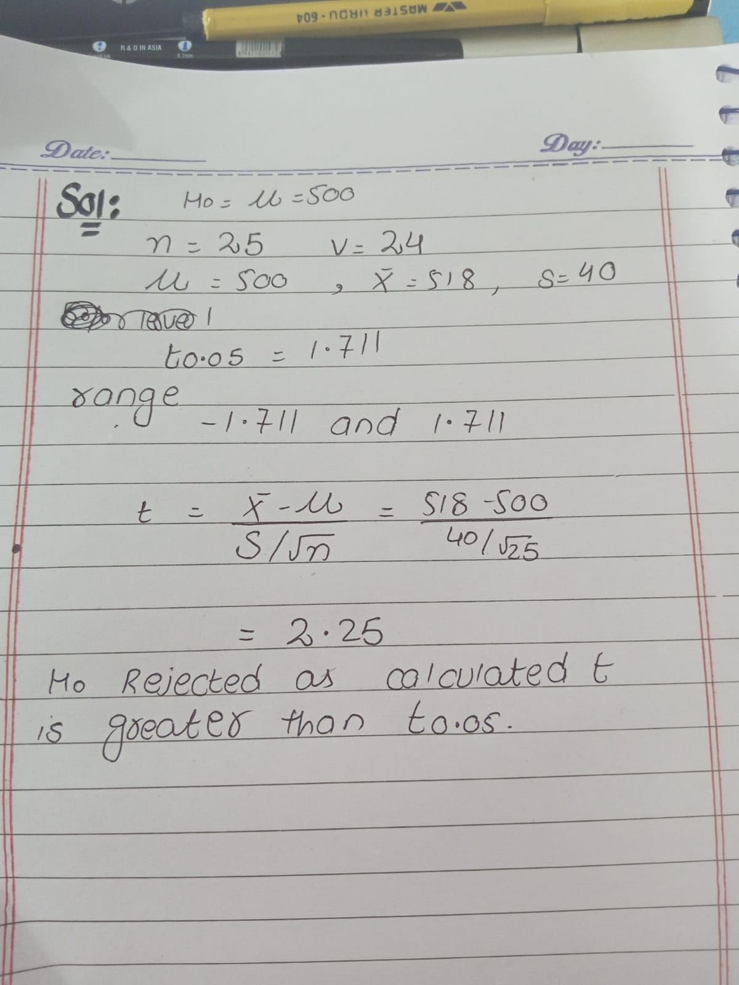

—----------------------------------------------------------------------------------------------------------------------------

Practice Question 2: Confidence Interval for Population Mean
A sample of 15 students was selected to estimate the average time they spend on homework. The sample mean is 2.8 hours, and the sample standard deviation is 0.6 hours. Construct a 95% confidence interval for the population mean.


